MSCM 684 First Project Report
Lorenzo Fusser (40246529)
Vinayak Challa (40366514)
November 02, 2026
Evaluating Models Examining Price in Airline Industry | Preliminary Analysis
Airline Price Volatility
Following Gillen and Mantin (2009), this analysis investigates the relationship between airline price volatility, route characteristics, and market competition. The dataset includes 17,970 observations across 599 origin-destination markets, with 30 observations per route.
Airfare volatility is calculated as the standard deviation of consecutive logarithmic changes in average fares paid within each market. A multiple linear regression model is estimated using route distance, average passenger volume, largest carrier market share, and lowest-fare carrier market share as explanatory variables.
The preliminary results indicate that route distance is positively associated with volatility, while the market share of the lowest-fare carrier exhibits a statistically significant negative relationship. Passenger volume and largest carrier market share are not statistically significant at the 5% level.
The model explains approximately 9.9% of the variation in airfare volatility across routes. Although the findings provide some evidence that route characteristics and airline competition are associated with price fluctuations, the limited explanatory power indicates that other factors may contribute to volatility. Furthermore, because the dataset contains period-level average fares rather than daily offered ticket prices, the results cannot directly replicate the booking-horizon analysis conducted by Gillen and Mantin (2009).

Dynamic Airfare Price Dispersion
Following Mantin and Koo (2009), this analysis investigates the relationship between airfare price dispersion, route characteristics, and market competition. The dataset contains 17,970 observations across 599 origin-destination markets, with 30 observations per route.
Price dispersion is measured using the coefficient of variation, calculated as the standard deviation of period-level average fares paid divided by their mean. A multiple linear regression is estimated using route distance, estimated passenger volume, largest carrier market share, lowest-fare carrier market share, and average airfare as explanatory variables.
The preliminary results indicate that route distance is negatively associated with price dispersion, while passenger volume and average airfare exhibit statistically significant positive relationships. The market shares of the largest carrier and lowest-fare carrier are not statistically significant at the 5% level.
The model explains approximately 19.6% of the variation in price dispersion across routes. These findings suggest that route characteristics and passenger traffic are associated with differences in airfare dispersion. However, the model is a simplified adaptation of Mantin and Koo (2009), as the dataset does not provide individual ticket prices or comparable booking histories needed to reproduce the original study's dynamic price dispersion measure.

Temporal Effects in Airfare Pricing
Building on Mantin and Koo (2010), this analysis investigates whether airline ticket prices and their variation exhibit systematic patterns across observation periods. The dataset contains 17,970 observations across 599 origin-destination markets, with 30 observations per market.
Two multiple linear regression models are estimated. The first examines average airfare paid, while the second examines the absolute deviation of each period's airfare from its route's overall average. Both models include a time index, its squared value, and route fixed effects.
The results indicate statistically significant nonlinear relationships between observation periods and both airfare levels and absolute price deviations. Average airfare exhibits an inverted-U relationship, while airfare deviations exhibit a U-shaped relationship. The models produce R-squared values of approximately 0.865 and 0.502, respectively, although these values also reflect the explanatory contribution of route fixed effects.
These findings suggest that airfare levels and their variability change systematically across observed periods. However, because the dataset does not identify calendar dates, the analysis cannot determine whether these patterns represent genuine weekday or weekend pricing effects, as investigated by Mantin and Koo (2010).

Time Series Plots of Average Airfare
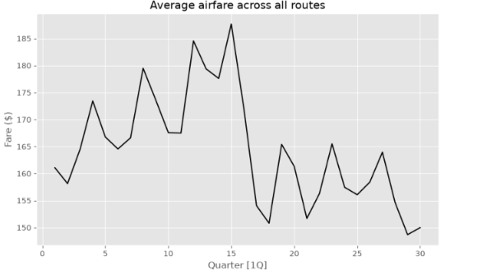
This section will look how the average airfare changes over time, and this is very important because the methods that were used for this were the Hyndman et al. (2026). This graph looks at the taking periods of time that is every 30 periods, while taking the average of that across all the 599 routes. This is valuable since the output will gives a series of 30 values that we can work with. The x axis of the graph is given by the quarter, and now there is a clear four period pattern than can established like a cycle. Additionally, since that has been established, we can say that each period of quarter is equated to about 7.5 years.
Now looking at the graph above we it can be illustrated that the average fare rises from about 161 dollars to the peak when it at quarter 15 or 4 of 188 dollars. This is sharp rise and this about 27 dollars. Now, when we look from quarter 15 to 18 we can see that there is a very sharp decline from 188 dollars to 151 dollars and this a decline of about 37 dollars. When looking at the rest of the graph it can we said they stay in the lower range from 150 to 165 dollars. Moreover, when comparing the results from the first 15 quarter to the last 15 quarters it can be said that there is a clear difference the first 15 was a lot better and last 15, for instance there is a average difference of 172 dollars to 158 dollars.

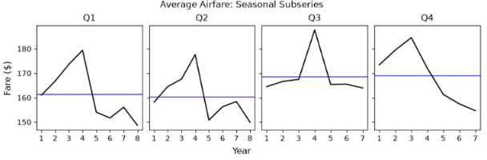
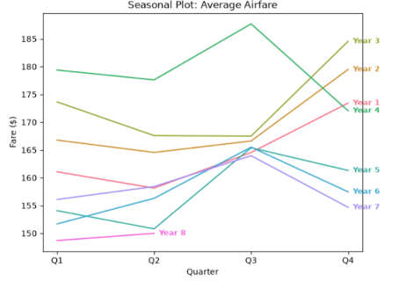
The seasonal plot and the seasonal subseries above show that when looking at the overall trend and understanding across all the quarters. There can be a conclusion made that the Q3 and Q4 are usually the most expensive quarters. There average is about 170 dollars for Q3 and Q4 while the average for Q2 and Q1 is about 160 dollars. However, there are different years in which the highest goes to certain quarters and this can be seen when years 1 to 3 have Q4 as their highest, while years 5 to 7 have Q3 as their highest.

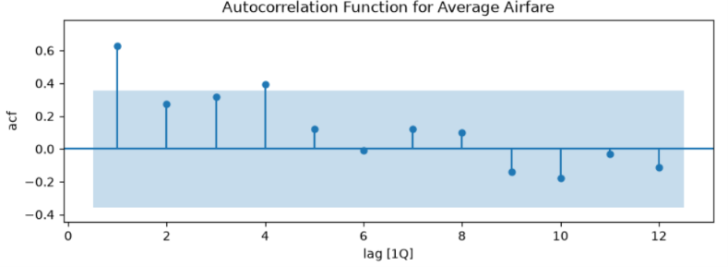
The graph above illustrates the autocorrelation function from average airfare, and from this graph it can be observed that there is strongest indication at lag 1(0.60). This means that each of the quarter’s fare is very similar and closely tied to the previous quarter’s fare. The lag 4(0.4) is just above the blue significance band which is made for the weak yearly patterns. Observing the rest of the correlations we can see they decline quickly and this means that there no strong long term trend visible.

Airfare Forecasting Models
In this section we are going to compare the following models the naive model means that the next fare is going to equate to the latest fare. The seasonal naïve and this one is going to represent that the next fare equates to same quarter of the previous year. Additionally, it is going to look at exponential smoothing, and each model is trained based on the quarters of 1 to 22 and tested on the remaining quarters of 22 to 30. These metrics are evaluated on the MAE, RMSE, MAPE, and MASE.
Model | MAE($) | RMSE($) | MAPE(%) | MASE
Seasonal Naive | 3.48 | 4.08 | 2.3 | 0.35
Naive | 4.49 | 5.59 | 2.9 | 0.45
Exponential Smoothing | 4.51 | 5.63 | 2.9 | 0.46

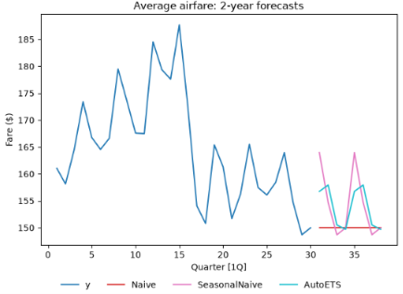
Observing the table above it can be apparent that the seasonal naive is the most accurate of them all and this is because the average error is about 3.48 dollars. However, when looking at the other ones we can see that that they are less accurate than the seasonal naive, however, their accuracy is about the same on average. This is supporting the graphs above.
Overall, when overseeing all the 30 quarters it can be concluded that the models expect the average fare to be around 150 to 165 dollars over the next couple of years.

Progress Report:
1. How have you broken the project into workflows?
Vish and I have divided the project workload equally (50/50). We are sharing responsibilities across the main stages, including literature review, data preparation, model development, performance evaluation, and report writing. We communicate regularly to discuss our findings, address any challenges, and ensure our work remains coordinated.
2. What has your group done so far?
So far, we have reviewed and analyzed the research articles provided on Moodle to better understand airline pricing behavior, price volatility, price dispersion, and the potential applications of AI in pricing decisions. We have also explored preliminary regression models based on these articles to better understand the dataset and identify relevant variables. These models will serve strictly as benchmarks for comparison and are not intended to be used as our final project models.
3. What are the plans for the upcoming weeks?
Over the coming weeks, we plan to complete data preprocessing and exploratory data analysis, followed by developing and refining our machine learning and GenAI models. We will then compare their predictive performance, identify the most suitable approach for supporting airfare purchasing decisions, and interpret the results. Our second progress report is scheduled for November 14, followed by the final report and presentation on November 21. The final deliverables will include a literature review, data preparation, exploratory analysis, model development, performance comparisons, and managerial recommendations.
4. How do you plan to proceed to build agentic models using GenAI?
We plan to develop a GenAI-based decision-support agent that analyzes historical airfare data, route characteristics, and market conditions to generate pricing predictions and purchasing recommendations. The agent would use a structured workflow to process relevant information, identify pricing patterns, and evaluate whether purchasing immediately or waiting could be more beneficial. We also intend to experiment with different prompts and compare the agent's recommendations against traditional machine learning approaches to assess their usefulness and consistency.
5. How do you plan to validate the models?
We plan to divide the dataset into training, validation, and testing sets. The training set will be used to develop the models, while the validation set will help compare different approaches and adjust model parameters. Finally, the testing set will provide an independent evaluation of the selected models' performance on unseen data. We intend to use performance metrics such as Mean Absolute Error (MAE), Root Mean Squared Error (RMSE), and R-squared to evaluate prediction accuracy and compare the effectiveness of our approaches.

